




MODEL | SP-20048 | SP-200512 | Configueable
- MAIN INFO
Rated Voltage | 48V | 51.2V
Rated Capacity | 200Ah
Battery Power | 9.6kWh | 10.24kWh
Battery Type | LFP
Cycling Lifespan | >6000 Cycles
Max.Parallel Capacity | 15 units |  | √
- CHARGE&DISCHARGE
Max.Charging Voltage | 54V | 57.6V | √
Dischare Cut-off Voltage | 40.5V | 44.8V | √
Max.Charging Current | 205A |  | √
Peak Charging Current | 210(1S) |  | √
Max.Discharging Current | 205 |  | √
Peak Discharging Current | 210(1S) |  | √
- GENERAL
Net Weight | 75KG | 82KG
Gross Weight | 89KG | 96KG
Product Size(L×W×H) | 560×500×260MM
Package Size(L×W×H) | 600×530×300MM
Communication | RS485/RS232/CAN/Wifi/Bluetooth |  | √
Storage Condition | 6months@25℃  3months@35℃  1month@45℃
Charging Temp.Range | 0℃ to 65℃（32°F to 149°F)
Discharging Temp.Range | -10℃ to 65℃（314°F to 149°F)
Cooling Method | Passive Cooling
- STANDARD
Transportation | UN38.3/MSDS/TDG
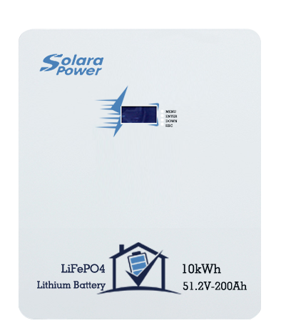
Wall-Mounted Energy
Storage Lithium
Battery
Solara Power
Use "core" to specialize "core".

